Driver Manager Certification Installation Steps

# Upon Clean Install

A “Security Warning” message will appear with **Publisher** as “Panasonic Corporation of North America”.

In order to bypass this message for future installations Continue With Certificate Install, otherwise continue with “Install”.

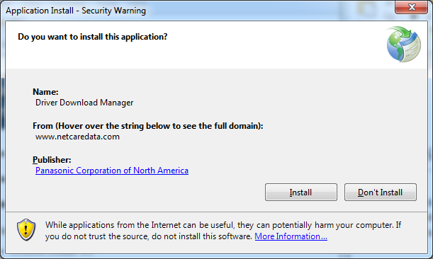

# Continue With Certificate Install

1. Click on “Panasonic Corporation of North America” link.

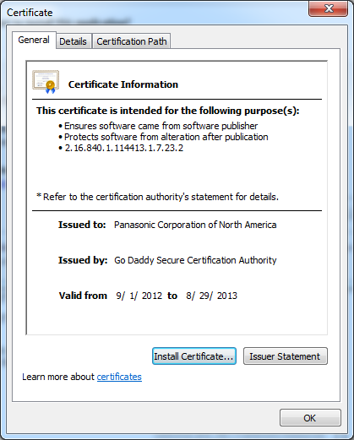

1. Click on “Install Certificate…” . Starting Wizard -> Click Next.
2. Select Radio button: “Place all certificates in the following store”.
3. Select “Certificate store:” to be “Trusted Publishers”.

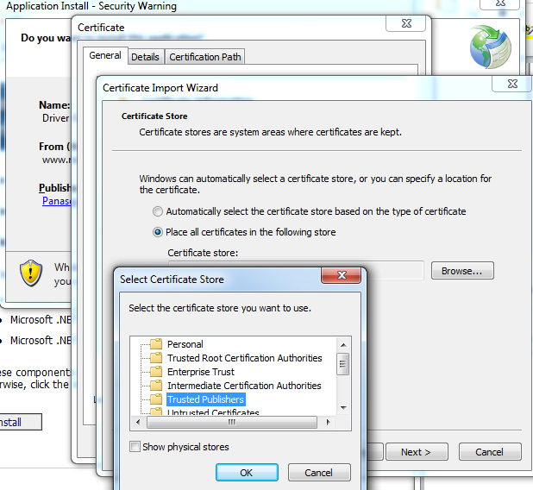

1. Finish the Wizard and continue with Install.

**For future installations - as long as the certificate still reside in users machine - the “Security Warning” message will be hidden.**